Solar Power Regulator with User Input

ELN9204 (Final Project)
April 21st, 2014
David Manouchehri

Owners Manual
This system provides a solar panel regulator and can be used independently. This manual will briefly explain how to setup the system, and will note any hardware or software limitations.

Contact Information
David Manouchehri
d@32t.ca

Setup
As shown in the schematics (attached at the end of this document), a battery (B1) will be plugged into one side of a mechanical relay (U5). It is important to ensure you are using a normally open contact, as the system will not work as expected with a normally closed contact.
If the user wishes to measure the current draw of a device, the resistor at R5 should be replaced with the desired device.
Once all devices have been plugged in, power on the device. Immediately the two LCD screens should begin to display information regarding the battery.

Setting Time
By default, the clock will begin at 0:0:0. To set the time, press the config button (PB1). A window should pop up on one of the LCD screens prompting the user to enter the hour; press the set button (PB2) to increment the time. To reset to zero, simply continue to press the set button until it restarts at zero. Once satisfied with the hour, press the config button to save it. Repeat this process to set the minute. After this is done, the device will resume it's standard operation.

Clearing Over-Voltage Error
If the battery voltage passes the set threshold (default 10V), the relay will disconnect the battery. To resume operation, first ensure that the voltage has been lowered to a safe level. Then, proceed to press either button to clear the error. The

Analyzing On-Screen Information
The information presented on screen will be the following:
- Light
- Battery Temperature
- Battery Voltage
- Load Current
- Time
- Battery Status (“GOOD” for standard operation or “BAD” for over-voltage)
Note: when in config mode, a limited amount of information will be displayed on the second LCD screen. To resume standard operation, simply set the time as described in the previous section.

Miscellaneous Report Information
During the testing of the circuit, it was observed that the speed of the chip was a limiting factor, as it had difficulty updating all the information in a reasonable time frame. It was later discovered that a part of the problem was the microcontroller's oscillator was accidentally set to 1 MHz instead of 8 MHz. This problem has been corrected in the attached version.
Another problem was the current reading; due to the low current passing through the load resistor, it was difficult to get an accurate reading. To help mitigate this issue the ADC was set to 10-bits instead of the default 8-bits. The breadboard also introduced extra noise which affected the readings. In a real world application it would be reasonable to assume a larger load is to be used, so this problem would be less pronounced.

Prototyping Circuit
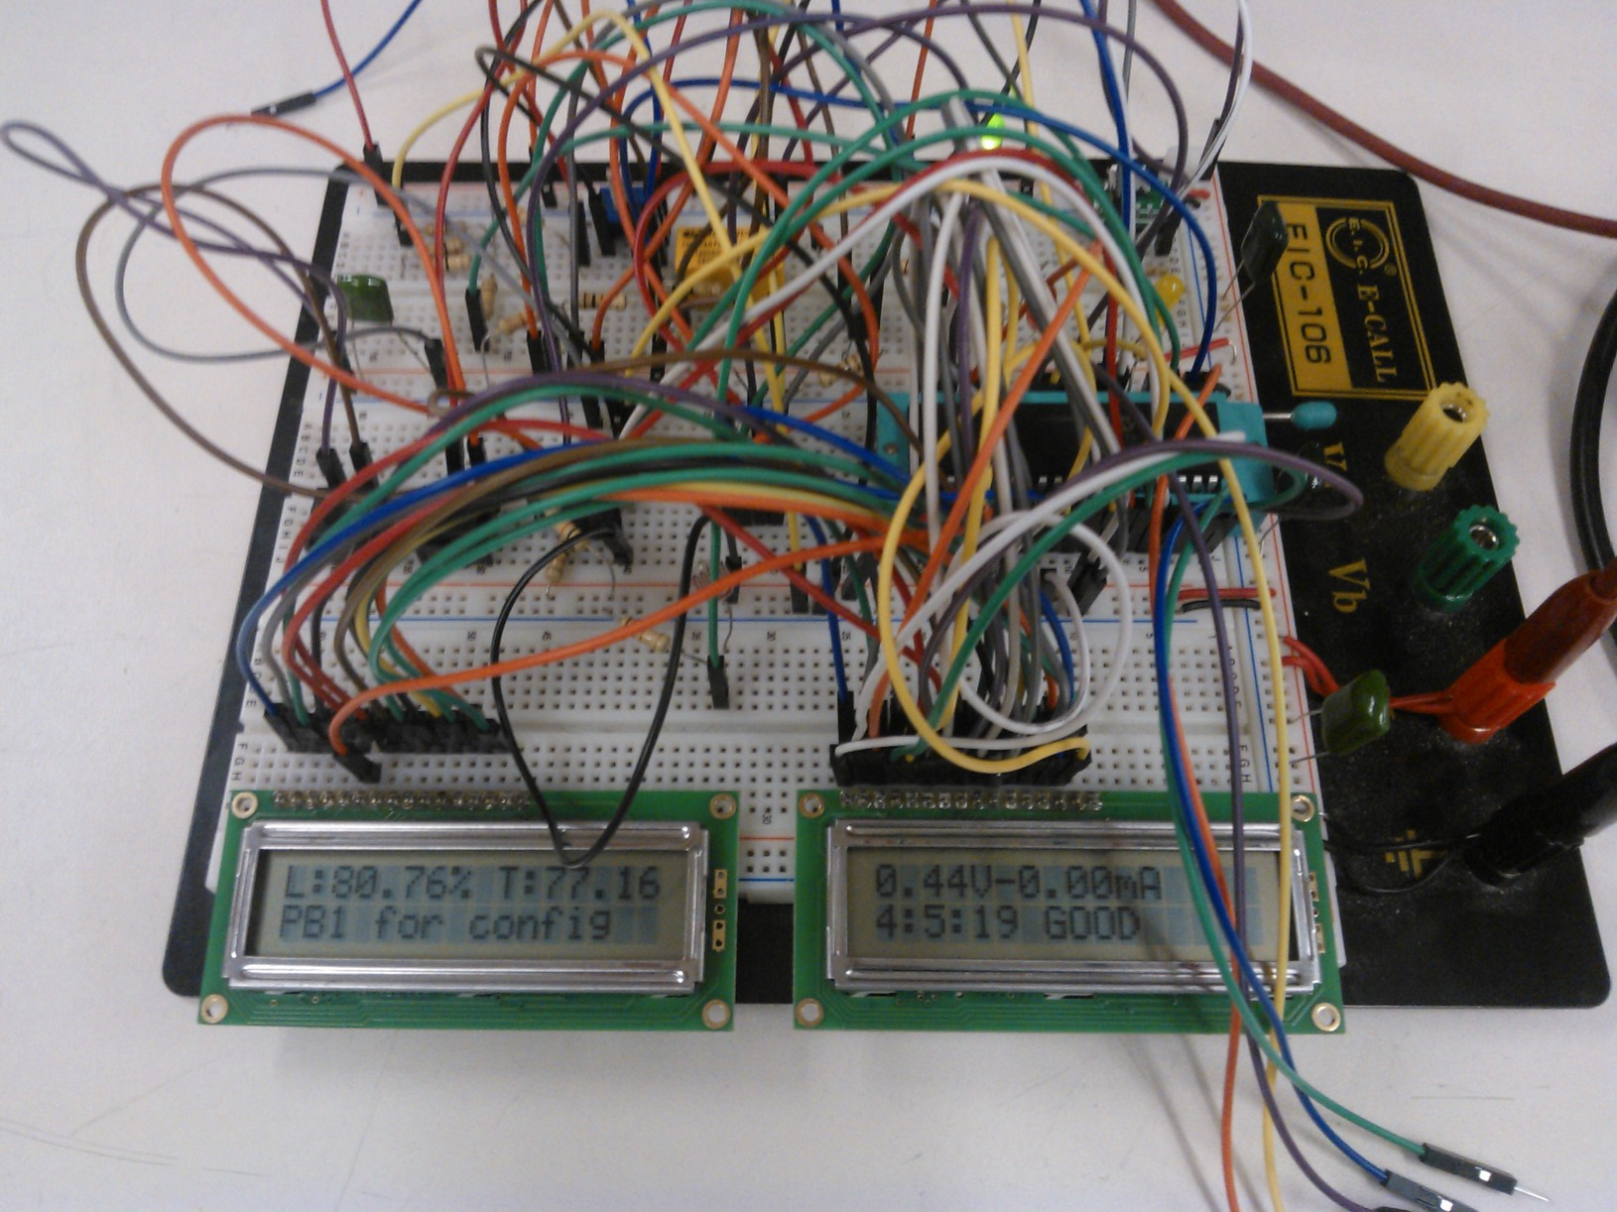Illustration 1: A prototype circuit running

Program
main.c
1 /*
2 * File: main.c
3 * Author: David Manouchehri
4 *
5 * Created on April 3, 2014, 9:24 PM
6 */
7
8 #include "config.h" /*All the pins are set in here*/
9 #include "lcd.c"
10 #include "ds1631.c"
11 #include "nju6355.c"
12 /*
13 *
14 */
15
16 /*Setup variables and set to default vaules*/
17 float tempValue = 0;
18 unsigned int16 reading = 0;
19 unsigned int16 light = 0;
20 unsigned int8 brightness = 100; /*Decent default value, in the future it could easily be adjustable*/
21 float voltage = 0;
22 float current = 0;
23 int hour, min, sec;
24 int1 configView = 0;
25 int1 errorBit = 0;
26
27 /*Basic IO setup, nothing too fancy.*/
28 void setupIO(void)
29 {
30 LCD_E = LCD_E0; /*Use LCD#1*/
31 setupLCD();
32 LCD_E = LCD_E1; /*Use LCD#2*/
33 setupLCD();
34
35 SETUP_ADC(ADC_CLOCK_INTERNAL);
36 setup_adc_ports(sAN0 | sAN1 | sAN2);
37
38 init_temp();
39 rtc_init();
40
41 pwm_set_duty_percent(brightness); /*Brightness setting, from a scale of 0 to 1000; a lower value makes the screens darker*/
42 }
43
44 /*This gets both the voltage and current through the resistor network*/
45 void getBattery(void)
46 {
47 set_adc_channel(0);
48 delay_us(10);
49 reading = read_adc();
50 voltage = (float)reading * 1000.0 / 1024.0 / 35.0 ; /*Cast to avoid rounding*/
51
52 set_adc_channel(1);
53 delay_us(10);
54 reading = read_adc();
55 current = (float)reading * 1000.0 / 1024.0; /*Because of the 10-bit ADC, scaling the current is quite easy; even without the scaling it's pretty accurate*/
56 }
57
58 void getTime(void)
59 {
60 rtc_get_time(hour, min, sec);
61 hour = rtc_rm_bcd(hour); /*This is needed to convert the value to BCD*/
62 min = rtc_rm_bcd(min);
63 /*Oddly enough seconds are handled differently than minutes and hours. No clue why, I'll probably have to look into the library later*/
64 }
65 void getTemp(void)
66 {
67 tempValue = read_full_temp ();
68 tempValue /= 100.0; /*Scale it down, and the .0 is there to avoid rounding*/
69 }
70
71 /*This function could be used later on for displaying warnings if the light gets too dark*/
72 void getLight(void)
73 {
74 set_adc_channel(2);
75 delay_us(10);
76 light = read_adc();
77 }
78
79 /*This is more or less the body of the program*/
80 void routineUpdate(void)
81 {
82 getBattery();
83 LCD_E = LCD_E1;
84 printf(putcharLCD, "\f%4.2fV-%4.2fmA ", voltage, current);
85 if(!configView) /*Use both LCD screens*/
86 {
87 getTime();
88 if((voltage > 10 && !errorBit) || errorBit) /*The !errorbit isn't actually needed, but I like having it there for reading*/
89 {
90 printf(putcharLCD, "\n%d:%d:%d BADCLRERR ", hour, min, sec);
91 output_high(LED3);
92 output_low(LED1);
93 output_low(RELAY);
94 errorBit = 1;
95 }
96 else
97 {
98 printf(putcharLCD, "\n%d:%d:%d GOOD ", hour, min, sec);
99 output_high(LED1);
100 output_low(LED3);
101 output_high(RELAY);
102 }
103
104 LCD_E = LCD_E0;
105 getLight();
106 printf(putcharLCD, "\fL:%4.2f%%", light * 1000.0 / 1024.0 / 10);
107
108 getTemp();
109 printf(putcharLCD, " T:%4.2f", tempValue);
110 printf(putcharLCD, "\nPB1 for config ");
111 }
112 else /*Only use one LCD screen, leave the other one alone for the config menu*/
113 {
114 getTime();
115 getTemp();
116 printf(putcharLCD, "\n%4.2f %d:%d:%d", tempValue, hour, min, sec);
117 LCD_E = LCD_E0;
118 }
119 }
120
121 /*This is probably the most confusing function to read through. Basically, it allows the user to adjust the current time*/
122 int getTimePB(char unit)
123 {
124 configView = 1; /*This automatically turns off one of the LCD screens for us later on in routineUpdate()*/
125 unsigned int8 time = 0;
126 unsigned int8 range = 0;
127 int1 blocking = 0;
128 getTime(); /*Update the current time to BCD before we start working with it*/
129
130 switch(unit) /*At the moment I'm just doing hours and minutes, but this makes it pretty easy to add anything else later on*/
131 {
132 case 'h':
133 range = 23;
134 time = hour;
135 break;
136 case 'm':
137 range = 59;
138 time = min;
139 break;
140 default:
141 range = 0; /*Throwing a compiler error would be a good idea to add*/
142 }
143 printf(putcharLCD, "\nthen PB1: %d ", time); /*Give the current value to the user*/
144 while(input(PB1)) /*Wait until the set button is released*/
145 {
146 if(!blocking) /*Don't run again unless the button has been released.*/
147 {
148 if(!input(PB2)) /*If it's pressed*/
149 {
150 if(time < range)
151 {
152 time++;
153 }
154 else
155 {
156 time = 0;
157 }
158 blocking = 1;
159 printf(putcharLCD, "\nthen PB1: %d ", time); /*Bit of a hack, I should manually set the location with the LCD. This wastes a few extra clock cycles*/
160 }
161 }
162 else
163 {
164 if(input(PB2)) /*Released, unblock*/
165 {
166 blocking = 0;
167 }
168 }
169 routineUpdate(); /*Just because we're at the config menu doesn't mean I want everything to freeze up!*/
170 }
171 return time; /*Gives back whatever value the user set*/
172 }
173 void setTime(void)
174 {
175 hour = rtc_get_bcd(hour);
176 min = rtc_get_bcd(min);
177 rtc_set_datetime (0, 0, 0, 0, hour, min); /*Just focusing on hours and minutes here. Too bad seconds aren't adjustable in the stock library*/
178 }
179 void configMenu(void)
180 {
181 /*Menu checking and setting*/
182 if(!input(PB1) && configView == 0)
183 {
184 while(!input(PB1)) /*Prevents blocking and some other nasty bugs*/
185 {
186 routineUpdate();
187 }
188 configView = 1; /*In short, we don't want to go to the config menu UNTIL the user releases the button*/
189 routineUpdate();
190
191 LCD_E = LCD_E0;
192 printf(putcharLCD, "\rHour with PB2, ");
193 hour = getTimePB('h');
194 setTime();
195
196 /*More blocking*/
197 if(input(PB1))
198 {
199 routineUpdate();
200 }
201
202 printf(putcharLCD, "\rMinute with PB2, ");
203 min = getTimePB('m');
204 setTime();
205
206 if(input(PB1))
207 {
208 routineUpdate();
209 }
210 }
211 configView = 0;
212 }
213 void main(void)
214 {
215 setupIO();
216
217 output_high(RELAY); /*We need the relay on to begin with*/
218
219 /*Another option would be to force the user to set the time to start with. Personally I like having it default to 0:0:0*/
220 hour = 0;
221 min = 0;
222
223 setTime();
224
225 while(1)
226 {
227 routineUpdate(); /*Assuming nothing interesting is happening, this gets run*/
228 configMenu(); /*Just check, may or may not run*/
229 if(!input(PB1) || !input(PB2))
230 {
231 errorBit = 0; /*Shut the error off, check the voltage again*/
232 }
233 }
234 }
config.h
1 /*
2 * File: config.h
3 * Author: David Manouchehri
4 *
5 * Created on April 11, 2014, 4:39 PM
6 */
7
8 #include <16F887.h>
9 #device ADC = 10 /*Use a 10-bit ADC instead of 8-bit*/
10 #fuses INTRC_IO, NOLVP, NOWDT, PUT /*Use internal clock*/
11
12 /*Define general I/O*/
13 #define LED1 PIN_C0
14 #define LED2 PIN_A4
15 #define LED3 PIN_A5
16 #define RELAY PIN_E0
17 #define PB2 PIN_C3
18 #define PB1 PIN_C4
19
20 /*Define pins for LCD*/
21 #define LCD_E0 PIN_C5
22 #define LCD_E1 PIN_B5
23 #define LCD_RS PIN_B4
24
25 /*Define pins for 6355*/
26 #define RTC_DATA PIN_B3
27 #define RTC_CLK PIN_B2
28 #define RTC_CE PIN_B1
29 #define RTC_IO PIN_B0
30
31 /*Define pins for 1631*/
32 #define DAL_SDA PIN_E1
33 #define DAL_SCL PIN_E2
34
35 #use delay (clock = 8MHz) /*Can be adjusted to anything below 8MHz with the internal clock*/
36 /*#use rs232 (baud=9600, xmit=PIN_C6, rcv=PIN_C7)*/ /*RS232 isn't really needed at the moment for anything; I've got the pushbuttons and LCDs doing all of the work*/
37 #use pwm (OUTPUT = PIN_C2, FREQUENCY = 32kHz, DUTY=50) /*Used for brightness*/

lcd.c
1 /*This entire library was taken from Stephen Ryan's example code, with some slight changes*/
2
3 int const LCD_INIT_STRING[5] =
4 {
5 0x38, // Func set: 8-bit, 2 lines
6 0x08, // don't shift display, hide cursor
7 1, // Clear display
8 6, // Increment cursor
9 0xc, // Display on
10 };
11
12 int LCD_E; /*This is to allow switching LCD screens instead of forcing one at compile time*/
13
14 void sendLCD(int address, int n)
15 {
16 output_low (LCD_E);
17 delay_us (60); /*Might be a little long?*/
18
19 if(address)
20 output_high (LCD_RS);
21 else
22 output_low (LCD_RS);
23
24 delay_cycles(1);
25 output_d (n);
26 output_high (LCD_E);
27 delay_ms (1);
28 output_low (LCD_E);
29 delay_ms(5);
30 }
31
32 void setupLCD(void)
33 {
34 int i;
35
36 output_low(LCD_E);
37 delay_ms(15);
38
39 for(i=0 ;i < 3; i++)
40 {
41 output_d (0x30);
42 delay_ms(5);
43 }
44
45 for(i=0; i < sizeof(LCD_INIT_STRING); i++)
46 {
47 sendLCD(0, LCD_INIT_STRING[i]);
48 }
49 }
50
51 void putcharLCD(char c)
52 {
53 switch(c)
54 {
55 case '\r':
56 sendLCD(0, 1);
57 delay_ms(2);
58 break;
59 case '\f': /*I had problems with /c, so that's why I changed it to /f*/
60 sendLCD(0, 0x80);
61 break;
62 case '\n':
63 sendLCD(0, 0xc0);
64 break;
65 default:
66 sendLCD(1, c);
67 break;
68 }
69 }

ds1631.c
1 ////////////////////////////////////////////////////////////////////////////
2 //// Library for a Dallas 1631 Temperature chip ////
3 //// ////
4 //// init_temp(); Call before the other functions are used ////
5 //// ////
6 //// d = read_full_temp(); Read the temp in degrees F (-67 to 257) ////
7 //// ////
8 //// This driver returns a high resolution value. For lower ////
9 //// resolutions use the DS1621.C driver as it is compatible with ////
10 //// the DS1631. ////
11 ////////////////////////////////////////////////////////////////////////////
12 //// (C) Copyright 1996, 2003 Custom Computer Services ////
13 //// This source code may only be used by licensed users of the CCS C ////
14 //// compiler. This source code may only be distributed to other ////
15 //// licensed users of the CCS C compiler. No other use, reproduction ////
16 //// or distribution is permitted without written permission. ////
17 //// Derivative programs created using this software in object code ////
18 //// form are not restricted in any way. ////
19 ////////////////////////////////////////////////////////////////////////////
20
21 #define read_temp read_full_temp // for backwards compatability
22
23 #use i2c(master, sda=DAL_SDA, scl=DAL_SCL)
24
25
26 void temp_config(BYTE data) {
27
28 i2c_start();
29 i2c_write(0x90);
30 i2c_write(0xac);
31 i2c_write(data);
32 i2c_stop();
33 }
34
35
36 void init_temp() {
37 output_high(DAL_SDA);
38 output_high(DAL_SCL);
39 i2c_start();
40 i2c_write(0x90);
41 i2c_write(0x51);
42 i2c_stop();
43 temp_config(0xc);
44 }
45
46
47 signed long read_full_temp() { // Returns hundreths of degrees F (-67 to 257)
48 signed int datah, datal;
49 signed long data;
50
51 i2c_start();
52 i2c_write(0x90);
53 i2c_write(0xaa);
54 i2c_start();
55 i2c_write(0x91);
56 datah=i2c_read();
57 datal=i2c_read(0);
58 i2c_stop();
59
60 data=(signed long)datah*100;
61 data=data+(((datal >> 4 )*(long)50)/16);
62 data=data*9;
63 data = (data / 5) + 3200;
64
65 return(data);
66 }

nju6355.c
1 ////////////////////////////////////////////////////////////////////////////
2 //// NJU6355.C ////
3 //// Driver for Real Time Clock ////
4 //// ////
5 //// rtc_init() Call after power up ////
6 //// ////
7 //// rtc_set_datetime(day,mth,year,dow,hour,min) Set the date/time ////
8 //// ////
9 //// rtc_get_date(day,mth,year,dow) Get the date ////
10 //// ////
11 //// rtc_get_time(hr,min,sec) Get the time ////
12 //// ////
13 //// rtc_get_bcd(data) Convert data to BCD ////
14 //// ////
15 //// rtc_rm_bcd(data) Convert data to int ////
16 //// ////
17 ////////////////////////////////////////////////////////////////////////////
18 //// (C) Copyright 1996,2013 Custom Computer Services ////
19 //// This source code may only be used by licensed users of the CCS C ////
20 //// compiler. This source code may only be distributed to other ////
21 //// licensed users of the CCS C compiler. No other use, reproduction ////
22 //// or distribution is permitted without written permission. ////
23 //// Derivative programs created using this software in object code ////
24 //// form are not restricted in any way. ////
25 ////////////////////////////////////////////////////////////////////////////
26
27 void rtc_init() {
28 output_low(RTC_CE);
29 output_low(RTC_IO);
30 }
31
32 void write_rtc_byte(unsigned int8 data_byte, unsigned int8 number_of_bits) {
33 unsigned int8 i;
34
35 for(i=0; i<number_of_bits; ++i) {
36 if((data_byte & 1)==0)
37 output_low(RTC_DATA);
38 else
39 output_high(RTC_DATA);
40 data_byte=data_byte>>1;
41 output_high(RTC_CLK);
42 output_low(RTC_CLK);
43 }
44 }
45
46 unsigned int8 read_rtc_byte(unsigned int8 number_of_bits) {
47 unsigned int8 i,data;
48
49 for(i=0;i<number_of_bits;++i) {
50 output_high(RTC_CLK);
51 shift_right(&data,1,input(RTC_DATA));
52 output_low(RTC_CLK);
53 }
54 return(data);
55 }
56
57 unsigned int8 rtc_get_bcd(unsigned int8 data)
58 {
59 int nibh;
60 int nibl;
61
62 nibh=data/10;
63 nibl=data-(nibh*10);
64
65 return((nibh<<4)|nibl);
66 }
67
68 unsigned int8 rtc_rm_bcd(unsigned int8 data)
69 {
70 unsigned int8 i;
71
72 i=data;
73 data=(i>>4)*10;
74 data=data+(i & 0x0F);
75
76 return data;
77 }
78
79 void rtc_set_datetime(unsigned int8 day, unsigned int8 mth, unsigned int8 year, unsigned int8 dow,
80 unsigned int8 hour, unsigned int8 min){
81
82 output_low(RTC_CLK);
83 output_high(RTC_IO);
84 output_high(RTC_CE);
85 write_rtc_byte(rtc_get_bcd(year),8);
86 write_rtc_byte(rtc_get_bcd(mth),8);
87 write_rtc_byte(rtc_get_bcd(day),8);
88 write_rtc_byte(rtc_get_bcd(dow),4);
89 write_rtc_byte(rtc_get_bcd(hour),8);
90 write_rtc_byte(rtc_get_bcd(min),8);
91 output_low(RTC_CE);
92 output_low(RTC_IO);
93 }
94
95 void rtc_get_date(unsigned int8 &day, unsigned int8 &mth, unsigned int8 &year, unsigned int8 &dow) {
96 output_low(RTC_CLK);
97 output_low(RTC_IO);
98 output_high(RTC_CE);
99 year=rtc_rm_bcd(read_rtc_byte(8));
100 mth=rtc_rm_bcd(read_rtc_byte(8));
101 day=rtc_rm_bcd(read_rtc_byte(8));
102 dow=rtc_rm_bcd(read_rtc_byte(4)>>4);
103
104 read_rtc_byte(8*3);
105 output_low(RTC_CE);
106 output_low(RTC_IO);
107 }
108
109 void rtc_get_time(unsigned int8 &hr, unsigned int8 &min, unsigned int8 &sec) {
110 output_low(RTC_CLK);
111 output_low(RTC_IO);
112 output_high(RTC_CE);
113 read_rtc_byte(8*3+4);
114 hr=rtc_rm_bcd(read_rtc_byte(8));
115 min=rtc_rm_bcd(read_rtc_byte(8));
116 sec=rtc_rm_bcd(read_rtc_byte(8));
117
118 output_low(RTC_CE);
119 output_low(RTC_IO);

